Iridoids (Amara pura) – nitrogen-free, non-toxic terpenoid compounds of plant origin. Bitters are often found in plant kingdom. They are referred to glycosides according to the chemical nature. Their aglycones are not enough studied in contrast to other glycosides. Most bitters were known as empirical names, that describe the origin, not the chemical nature. For example, glycoside found in taraxacum is taraxacin, in Menyanthes trifoliata – menyanthin, in gentian – gentiopicroside.
Iridoids are found in many medicinal plants and may be responsible for the some of their pharmaceutical activities. Isolated and purified, iridoids exhibit a wide range of bioactivities including cardiovascular, cholerectic, hypoglycemic, analgesic, anti-inflammatory, antimutagenic, antispasmodic, antitumor, antiviral, immunomodulator, and purgative activities.
The iridoids are produced by plants primarily as a defense against herbivores or against infection by microorganisms. To humans and other mammals, iridoids are often characterized by a deterrent bitter taste. They have bitter taste and used for stimulation and improvement of appetite.
Other organic compounds, produced by plants, have bitter taste. But all these compounds have a high toxicity (some alkaloids, cardiac glycosides).
Chemically, the iridoids usually consist of a сyclopentane ring fused to a six-membered oxygen heterocycle. The chemical structure is exemplified by iridomyrmecin, a defensive chemical produced by the Iridomyrmex genus, for which iridoids are named.
Bitters are divided into 2 groups according to the related substances:
1. Bitters (Amara pura) can be found in plant organism with volatile oils, these iridoids are called aromatic iridoids.
2. They can be found also with mucilage, these bitters are called mucilaginous bitters (Amara mucilaginosa).
Bitters are divided into 3 groups: pure bitter- amara pura or aroma tonica, aromatic bitter- amara aromatica and spices-amara acria. Medicinal plants containing amara aromatica will be considered in the “Volatile oils” section. Amara tonicas are mainly presented by iridoids and monoterpenoid glycosides.
The information of the medicinal bitter – containing plant material used in medical practice is presented in 1 table about
Table 1. The medicinal plant material used in medical practice
MPM name | Class of biological active substances | Bitterness value | Constituents
Classic bitters – Amara tonica
Gentianae radix – Radices Gentianae | Iridoids | 10 000-  30 000 | Gentiopicrin and its isomers
Centaurii herba – Herba Centaurii | Iridoids | 10 000 | Eritrocentaurine
Menyanthes leaves– Folia Menyanthydis | Iridoids | 4000-10 000 | Folimenthin, loganin, sveroside and oth.
Dandelion root – Radices Taraxaci | Sesquiterpenes  lactones |  | Evdesmanolides and germacranolides
Chicory root – Radices Cichorii intybi | Sesquiterpenes  lactones |  | Lactucine, lactucopicrin
Artichoke leaves – Folia Cynarae | Sesquiterpenes  lactones and phenolic acids |  | cynaropicrin; cynarine, chlorogenic acid
Aromatic bitters – Amara aromatica
Artemisia herba – Herba Artemisiae absinthii | Sesquiterpenoids | 10 000-  25 000 | Absinthin, anabsinthin, artabsin
Achillea herba – Herba Millefolii | Sesquiterpenoids |  | Guaianolides, Evdesmanolides (tauremisine), germacranolides
Rhizomes of acorus – Rhizomata Calami | Sesquiterpenoids |  | Acorone, elemol, acorenone, acoric acid
Пряности с горько-острым вкусом – Amara acria
Wood of quassia – Lignum Quassiae | Triterpenoids | 40 000-  50 000 | Quassin
Ginger rhizome – Rhizomata Zingiberis | Seskviterpeno-idlər və fenilalkanlar |  | Zingiberene, gingerol
Fruits of Capsicum annuum – Fructus Capsici | Amides (protoalkaloids) |  | Capsaicinoids
Other medicinal plant material containing bitters
Cinchona bark – Cortex chinae | Alkaloids |  | Quinine
Cone of Humulus lupulus - Strobili Lupuli | Phenolic compounds – phloroglucinol derivatives |  | Bitter acids– humulone, lupulone and oth.
Herb motherwort– Herba Leonuri | İridoids, diterpenes |  | leonuride, ayuqgol, ayugoside, marrubin
Bitter orange bark – Pericarpium Aurantii amari | Flavanones, triterpenoids - limonoides | 600-1500 | Neohesperidin, naringin;  Limonin

Classification
- Cyclopentan types
According to number of C atom in skeleton of aglycon they could be divided on 4 types: С8, С9, С10 and С14.
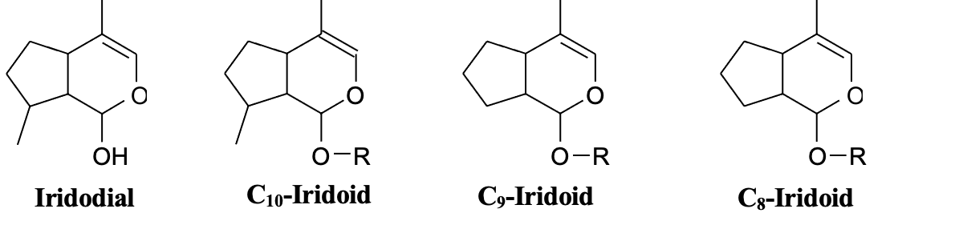
Iridoids are typically found in plants as glycosides, most often bound to glucose.
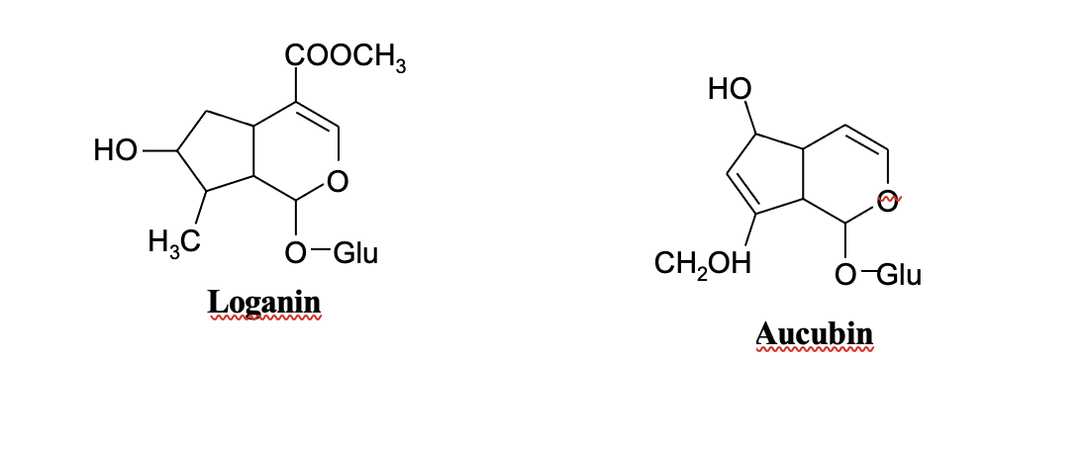
- Secoiridoids. Cleavage of a bond in the cyclopentane ring gives rise to seco-iridoids.
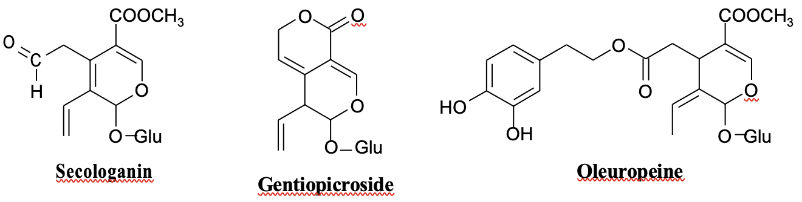
- Iridoids of plants from family Valerianaceae. Bicyclic monoterpenes or valepotriates (“Valeriana - Epoxy - triester”).
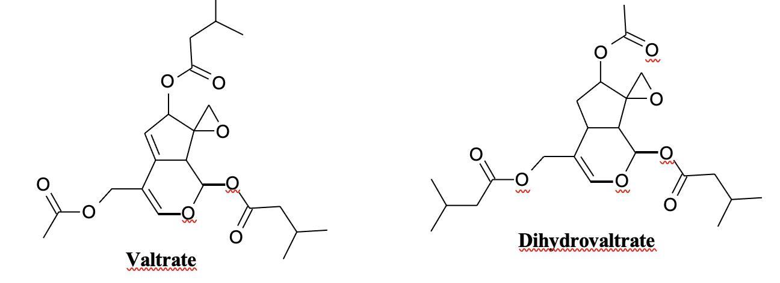
Bitters are classified into 4 types according to the chemical strusture:
1. Monoterpenoids (iridoids, pseudoindicanes) - (C₅H₈)_{2.} These are cyclopentane monoterpenes. The name of iridoid is associated with iridodial, isolated from Iridomyrmex ants. The name of pseudoindicane is associated with the formation of blue colour in acid medium. The bitter substances of plantaginaceae family– aukubin, menyanthes trifoliata – loganin, the centaurium species – gentiopicrin, valeriana officinalis – valtrates are referred to this group of iridoids.
2. Sesquiterpenoids - (C₅H₈)₃. Bitters of this group according to the structure are divided into the guayan (Artemisia absinthium, Achillea millefolium), acorane (Acorus calamus), eudesman, germacrane (Taraxacum officinale).
3. Diterpenoids - (С₅Н₈)₄. The bitters of this group are picrasma and quassin.
4. Triterpenoids - (С₅Н₈)₆. Cucurbitacines (toxic), taraxacin, taraxacerine (taraxacum officinale) are referred to this group.
All terpenoid iridoids are strongly oxidated, and have carboxy-, hydroxy-, etoxy-, oxo- lactone and ester groups.
Iridoids. According to the chemical composition iridoids are referred to monoterpenoids. Iridoids are compounds containing cyclopenthan monoterpenoid and at least 2 atomes of oxygen. The simpliest skeleton – iridodial- has the empirical formula C₁₀H₁₆O_{2.}
Iridoids are compounds mainly containing 10 carbon atoms. They also contain 9 or 8 carbon atoms.
Iridoids are divided into three groups:
1.Iridoid glycosides
2.Secoiridoid glycosides
3. Non glycosidic iridoids
Iridoid glycosides is transparent, crystalline or white hygroscopic powder. It is highly soluble in water, and insoluble in chloroform and petroleum ether. They are optically active substances. They have a bitter taste.
Secoiridoid glycosides are obtained form iridoid glycosides. C-C bond is formed between C-7 and C-8 from cycklopentane of iridoids. Secoiridoid glycosides - amaragentine, gentiopicrin and oleuropein –are transparent, crystalline substances, and optically active compounds. They are partly soluble in water in contrast to iridoid glycosides. In secoiridoid glycosides – amarogentin, amarosverine and oleuropein carboxylic acids are connected to glucose by ether bond. The reaction with phenolic reagents enables to detect them on chromatograms or carry out the quantitative determination by photometric method. HPLC is widely used for quantitative determination.
Bicyclic monoterpenes or valepotriates (“Valeriana - Epoxy - triester”). Valepotriates are white crystalline substances. They are poorly soluble in water, but easily soluble in lipophilic solvents. During the long storage the smell of isovalerianic acids is produced. Burning, bitter taste.
Valepotriates are iridoids with 10 carbon atoms. OH-group is necessarily located in С₁, the secondary OH-group – in С₇, primary OH-group in С₁₁. The third OH-group is connected with low molecular acids ( acetic acid, isovaleric acid, oxyacetate isovaleric acid). Epoxide ring is located between С₈ and С₁₀ carbon atoms.
Valepotriates have acid and alkaline properties. Alcohol solutions are fast splitted. Splitting in the solution of lipophillic compounds occurs slowly. Part of valepotriats are splitted by oral use. Valepotriates are divided into 2 types: dyen and monoyen.
O
A
C
3
O
A
C
1
O
2
C
A
O
A
C
3
O
A
C
1
H
H
O
O
Dyen type Monoyen type

Note: AC (acetate)
AC₁, AC₂ и AC₃ -2 (acetyl) 5 (isovalerinoil) and 7 (acetoxyvalerinoil) – are compounds of carboxylic acids with short chain.
Iridoids are widely found in plant world. Iridoids occur mostly in Lamiaceae, Scrophulariaceae, Plantaginaceae, Rubiaceae, Gentianaceae and Compositae. They are located in all organs of plants.
The identity of medicinal plant material containing bitters confirmed by organoleptic characteristics. The dilution with the lowest concentration still has a bitter taste. Drugs containing bitters are prescribed 15-20 minuts before a meal. They are used for treatment of hipoacid and chronic atrophic gastritis with cholagogic and oth. Bitters are contraindicated in states of hyperacid gastritis, stomach and duodenal ulcers. The researches of the countries of Europe and America, especially Japon take a greater interest in this group of compounds last years. Based on the result of research conducted by them about 60 iridoid glycosides were isolated and studied.
Iridoids are formed in plants by an alternative cyclization of geranyl diphosphate. The structures of these compounds are based on a cyclopentan-[C]-pyran skeleton, carbocyclic iridoids, and oxidative cleavage at the 7,8-bond of the cyclopentane moiety affords the so called secoiridoids.
On biogenetic grounds the iridoid formation may be considered to start from iridodial cation and follow diversification through 27 different routes. Iridoids have been used as chemical markers for the Corniflorae, Gentianiflorae, Loasiflorae and Lamiiflorae superorders.

Biosynthesis of Iridoids
The predecessor of iridoids is geranylpirophosphate as in other monoterpens. It is subject to cyclization reaction and follows the aldehid-iridodial step, then converts to 10-C-iridoid.

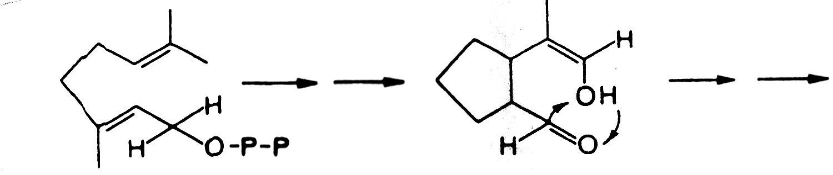

Gernayl pyrophosphate iridodial
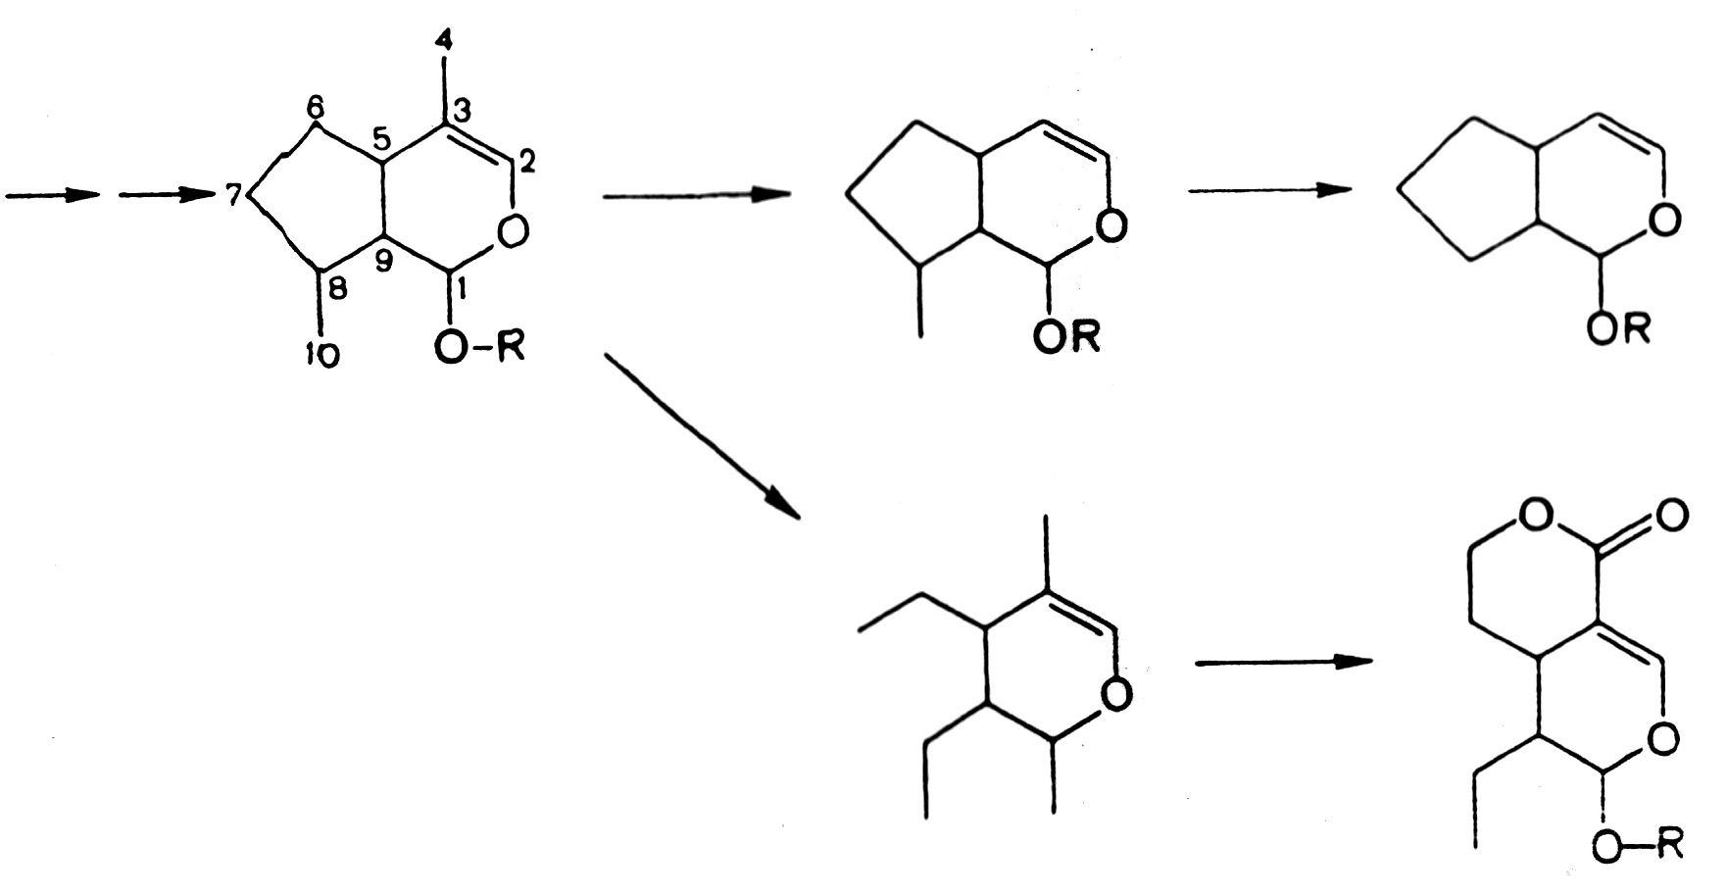
10-C-iridoid
9-Ж-iridoid
8-Ж-iridoid
Secologanine type
Entiopicroside type
Secoirioids

Futher biogenetic changes could take place in plants by formation of iridoid with fewer carbon atoms – 9,8,7. The five-membered cycle can be opened and formed secologanin or complicated cyclic compounds –gentiopicroside.
Physical and chemical properties.
- Colorless liquids or crystals (sometimes amorphous) substances.
- Bitter compounds, often have a bitter taste.
- Most of them are freely soluble in water and low molecular weight alcohols.( ethanol, acetone, methanol). But there are also iridoids that sparingly soluble in water and a bit better – in ethylacetate.
- They occur as glycosides or complex epoxides in plants
- Aglycons of iridoids are non-stable: they are sensitive to enzymes and acids, while acetylated iridoids to alkali.
- When treated by acids or under the influence of enzymes in presence oxygen, iridoids form colored (dark blue or violet- blue) non-solved in water products.
- The blacking of plant raw material during the drying is indicative of the presence of iridoids. It is due to enzymatic degradation to free aglycones, that freely oxidized and polymerised and form dark coloured pygments.

The extraction of iridoids from plant raw material
Universal extraction method for iridoids from plant raw material does not exist. Considering the hydropilicity of these substances the main extraction method from the plant material is the extraction with water or a mixture of water and alcohol. The following scheme of extraction iridoids could be proposed.
Add 50% solution of methanol as extragent to the weighed amount of plant material. The alkaline medium is formed to remove the organic acids. For this purpose the calcium cabonate is added to this solution when mixing. The extraction of iridoids is conducted under heat. The extraction is concentrated under vacuum till water residue, then add petroleum ether to purify from lipohyl susbtances. The water solution is passed through a chromatographic aluminum oxide column for the removal of phenolic compounds. The aqueous filtrate is dried, the residue is dissolved in ethanol, then acetone is added to precipitate polysaccharides, saponins and other compounds. The precipitate is filtrated, the filtrate is concentrated under vacuum and left at reduced temperature for iridoid precipitation.
For obtaining of pure sum of iridoids the plant material is extracted with 50% ethanol (4:10) under heat. The extraction is filtered and separated, the solvent is added, that 5 times more that the extract, and it is extrated under the heat. Obtained extracts are mixed and distilled under vacuum till complete separation of alcohol and store in the fridge until the next day. Resins and chlorophyll are precipitated. The precipitate is removed, filtrate of extract is treated with petroleum ether and passed through chromatography column, filled with polyamide or aluminium oxide. Columns are washed with water or aqueous alcohol. Eluate is heated on a boiling water bath to evaporate to dryness, the resodue is dissolved in a small amounts of alcohol and the impurities are precipitated with acetone. So, the pure sum of iridoids are crystallized by the mixture of ethanol – acetone (1:3), then ethanol- chloroform (1:1).
The extraction purification and isolation of individual substances are conducted by the partition column chromatography.

Qualitative reactions and chromatographic analysis of iridoids.
For detection of iridoids the raw material is extracted with 10 volumes of 80% ethanol on the water bath. Isolated extracts are mixed, and evaporated in a water bath, concentrated under vacuum to formation of resinous mass and dissolve in the same solvent at a ratio 1:10.
It is chromatographed on paper by upward method in the system of various solvents ethyl acetate – acetic acid – water (10:2:3), n-buthanol – acetic acid – water (4:1:2).
Iridoids are detected as the coloured spots after spraying chromatogram with appropriate reagents:
- 10% alcohol solution of sulfuric acid
- 5% solution of hydrochloric acid
- Bacon- Edelman reagent (0,5 g benzidine, 10 ml acetic acid and 100 ml ethanol)
- The Stahl reagent is used in analytical practice. Most of terpenoid nature substances are reacted with this reagent. Reagent Stahl (20 ml of 1% ethanol solution, p-dimethylaminobenzaldehyde and 1 g sulfuric acid)
- The solution of vanilin in methanol (1 g vanilin, dissolve 3 ml concentrated sulfuric acid in 150 ml methanol) After spraying with reagent, the chromatogram is heated in thermostat at 100-110 ⁰C for 3-5 minutes. The spots of iridoids become blue, blue-purple, green and red-brown colours.
- The reaction of Trim-Hill (copper sulfate in concentrated medium) is often used for detection of iridoids in plant raw material. Despite this, the reaction is common, some iridoids are not detected by this reaction.
Thin-layer chromatography is used for detection of iridoids. Separation of the iridoids in mixture is achieved when using fo various systems of solvents. Ethyl acetate with aqueous alcohols or acidic solutions are usually used for thin-layer chromatography.
The identification of iridoids is carried out by physical and chemical studies: determination of elemental composition, melting point, mobility on chromatogram and comparison with standard sampls, interpretation UV-, IR-, NMR- , mass- spectrs; study of acetylation, saponification, acid and enzymatic hydrolysis.

Quantitative determination of iridoids
The quantity of iridoids in plant raw material is determined by physical and chemical methods. However, during the study of pure bitters at first the bitterness value is established.
The bitter properties of plant material are detemined by comparison with quinine hydrochloride. Recognition thresholds of bitter are the minimum levels of concentration of solution, to feel the bitterness in 30 sec.
The bitterness value is expressed in units equivalent to the bitterness of a solution containing 1 g of quinine hydrochloride in 2000 ml of water.

Biological activity. The carrieer of biological activitiy is aglycone part of molecule. The use of bitters is based on reflexes to digestive tract.
The medicinal plants containing iridoids have a broad spectrum of pharmacological acitivity and widely used in medical practice for different diseases. Pharmacological study of iridoids and creation of drugs have an important significance. It was found, that iridoids (for example aucubin) are bacteriostatic, anti-inflammatory, wound-healing, cholagogue, diuretic and oth.
Secoiridoids (gentiopicroside type) increase appetite, stimulate digestion, increase the gastric juice. Bitters stimulate the buds of the tongue and act on digestive organs by reflex.
All bitters are prescribed in hypoacid and chronic atrophic gastritis with cholagogue and other drugs. Bitters are contraindicated in hyperacid gastric secretion, duodenal and stomach ulcer.
Iridoids are distributed unequally, that’s why their study enables to receive an important information of chemistry, taxonomy and medicinal properties of these compounds.

Medicinal Plant and Raw Material Containing Bitter Principles
Bitter principles (Amara) are heterogenous compounds of bitter taste. The chemistry of bitter principles has been studied in many cases incompletely. This group comprises natural vegetable products belonging to different chemical groupings.
GENTIAN ROOT - GENTIANAE RADIX
Gentian - Gentiana lutea L., Fam. Gentianaceae.
Synonym(s): Yellow gentian.
Plant. It is an up to more than 1 m in height perennial, herbaceous mountain plant. It has opposite, oval, bluish green, robust leaves; auxillary flowers with 5, rarely more, yellow petals.
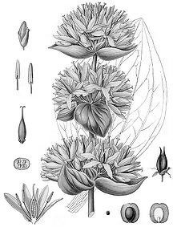
Area of distribution. France, Spain, the Balkans, Ukraine (Carpathian Mountains) (where the roots are obtained from wild plants). There are small-scale plantations in France and Germany (where the plant is fully protected).Yellow gentian grows in the mountains and would remain from the times of glaciation. It grows in fields and pastures over altitude of 800 m, evoking big candlesticks someone would have placed here and there.
Description. The drug consists of the brownish or reddish brown roots, which are up to several centimetres thick and often fragments of the rhizome, which transversely wrinkled on the surface; the roots are longitudinally grooved. In the transverse section of the broken drug, there is a relatively narrow bark (with a coarsely wrinkled cork), a distinct ring of cambium delimiting the xylem. The odour is weak and peculiarly sweetish, reminiscent of dried figs; the taste is sweetish at first, then persistently and intensely bitter.
Constituents. The root contains: secoiridoids bitter principles: the main component is gentiopicroside (1 to 3,5 %). The root has a very high bitter value 58000000.
Other constituents are xanthone derivatives (gentisin, isogentisin, gentioside, etc.); the darker internal colour of the dried European root as compared with the dried Japanese product, may be due to greater hydrolysis of the colourless glycosides to the yellow xanthones during the drying process. Besides saccharose and the trisaccharide gentianose, there is the bitter-tasting gentio- biose (5 -8%); phytosterols and pectins, or similar gel-forming substances, which may be responsible for the considerable swelling that the drug undergoes when moistened are also present. The alkaloids that have been described in the literature, e.g. gentianine, are probably artefacts arising during work-up. The small amount of the essential oil obtained on distillation has a complex composition. Starch is absent.
Uses. Gentian has antiasthenic, anti-inflammatory and antipyretic properties. By stimulating the taste buds of tongue and influencing especially the encephalic phase of secretion, the drug brings about reflex promotion of the gastric juice and saliva production; it is also has cholagogic effect. Used externally the plant heals sores. It is used chiefly in numerous prepared gastrointestinal remedies, as the powdered drug or extract, tincture, percolate, etc., e.g. Aciphyt® (drops), Gastricard® (tablets, drops), Ventrodigest® (tablets), etc., but also in the cholagogues or roborants and tonics. Homoeopathic dilutions of gentian root are also present in more than a dozen preparations.
Among the UK multi-ingredient products containing gentian root and/or extracts of it are: Lanes Kalms Tablets, Potter's Appetiser, Indigestion, and Stomach Mixtures; Seven Seas Nerve Tablets; Effico® contains compound gentian infusion.
Gentian is extensively used to make liqueurs. Gentian is used in cosmetic for its softening and purifying properties. It is moreover a good tonifying agent. Gentian is also recommended for its astringent properties. The plant is a good ingredient in shampoos and lotions for greasy, damaged and delicate, dull and limp hair; body milks; soothing hand creams. Contraindications: Stomach and duodenal ulcer.
Side Effects: In predisposed persons headache may develop.
Pharmacopoeial and Other Monographs: DAB, Ph Helv., BHP, Ph. Eur. 6.4, BP 2009.

BOGBEAN LEAF - MENYANTHIDIS FOLIUM
Bogbean - Menyanthes trifoliata L., Fam. Menyanthaceae. Synonym(s): Buckbean, Marsh trefoil leaf.
Plant. Perennial marsh plant, up to 30 cm in height, with termite leaves. Flowers are while, petals are bearded on the inside.
Area of distribution. Damp localities in the northern temperate zone. The drug is imported from the former USSR. Poland, former Yugoslavia, and Hungary.
Description. The leaves are ternate ("trefoil"), with 1 ca. 10 cm
long petiole, and the individual leaflets are 5-10 cm long, elliptic, glabrous and with an entire margin. The leaf fragments of the cut drug are grayish green, partly with the shriveled, brownish nerves: because on drying the aerenchyma shrivels more, the fragments of the thicker petiole are wrinkled and longitudinally grooved. Very occasionally, petiole fragments with the three points where the leaflets were attached are recognizable. There is no odour. The taste is very bitter. Constituents. The bitter substances are the secoiridoid glycosides dihydrofoliamenthin, ment hiafol in and logan in, monoterpenoid alkaloids gentianine and geritianidine are possibly artefacts arising during the isolation procedure. Flavonoids, particulare hyperoside and rutoside, coumarins in small amounts are also present.
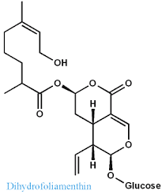 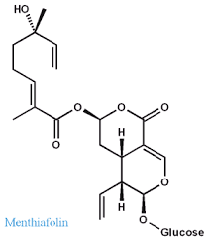 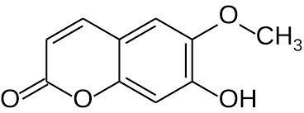 Scopoletin. 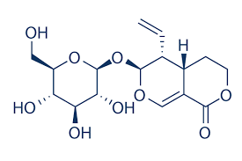Sweroside
Uses. Bogbean is stated to possess bitter and diuretic properties. It has been used for rheumatism, rheumatoid arthritis, and specifically for muscular rheumatism associated with general asthenia. Contraindications: Excessive doses may be irritant to the gastrointestinal tract, causing diarrhoea, griping pains, nausea and vomiting.
Pharmacopoeial and Other Monographs: BHP 1996, BP 2009, Complete German Commission E, Martindale 35th edition, Ph. Eur. 6.4, SPU.
CENTAURY HERB –CENTAURII HERBA
Centaury - Centaurium erythraea Rafn., Fam. Gentianaceae. Synonym(s): Centaurium minus Auct, C. umbellatum Gilib., Common Centaury, Erythraea centaurium (L.).
Plant. A biennial, only 30 cm in height producing a basal rosette of elliptical to spathulate leaves in the first year and a branched (lowering stem bearing small sessile, 5-part pinkish red, tubular flowers in flat umbels in the second year.
Area of distribution. Scattered to widespread in Europe, North
America, North Africa, and western Asia. The drug is imported from Morocco, former Yugoslavia, Bulgaria, and Hungary.
Description. Prominent features of the drug, which consists of aerial parts of the flowering plant, are the mostly yellowish, 4-angled, hollow pieces of stem and the up to 8 mm long reddish flowers. Fragments of the small, entire, and glabrous opposite leaves, on the other hand, are less conspicuous. Occasionally waved dehiscent fruits are present, together with the loose, very small seeds discharged from them. Another characteristic feature is the anthers, which become spirally twisted after releasing their pollen.
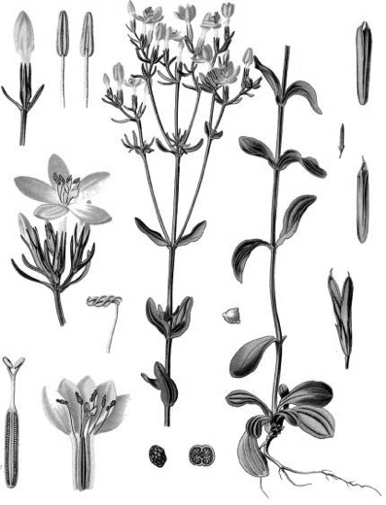
Constituents. Small amounts of intensely bitter-tasting secoiridoid glycosides, gentiopicroside (about 2%) as major, others include centapicrin, gentioflavoside, sweroside and swertiamarin; intensely bitter m-hydroxybenzoyl esters of sweroside and catapicrin.
Among triterpenoids it includes α- and β-amyrin, erythrodiol, crataegolic acid, oleanolic acid and sitosterol.
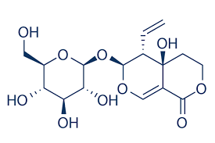Swertiamarin 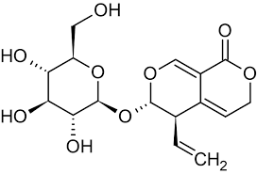Gentiopicrin

Herb contains highly methylated xanthones, including eustomin and 8-demethyleustomin; phenolic acids - vanillic, syringic, p-coumaric, ferulic, sinapic and caffeic; pyridine-type alkaloids; traces of gentianine, gentianidine, gentioflavine and flavonoids, fatty acids, alkanes and waxes.
Uses. Centaury is reputed to act as a bitter, aromatic and stomachic remedy. Traditionally, it has been used for anorexia and dyspepsia. Drug: Canephron N, Herbion Drops for the Stomach, Original Grosser Bittner Balsam.
Contraindications: Centaury is contra-indicated for individuals with peptic ulcers. Pharmacopoeial and Other Monographs: BHP 1996, BP 2009, Complete German Commission E, ESCOP 2003, Martindale 35th edition, Ph. Eur. 6.4.

DANDELION ROOT – TARAXACI RADIX
Dandelion - Taraxacum officinale Weber, Fam. Asteraceae.
Synonym(s): Lion's Tooth, Leontodon taraxacum L., Taraxacum.
Plant. A cosmopolitan in meadow along roadsides with a stout taproot and runcinate, basal leaves. The flowering heads consist only of ligulate flowers, the white pappus enabling the achenes to float in the air. Latex presents throughout the plant.
Area of distribution. Native throughout the northern hemisphere, with
many varieties and mi- crospecies; introduced into South America. The drug is collected from both wild and cultivated plants. The main suppliers are Bulgaria, former Yugoslavia. Romania. Hungary, and Poland; it is also obtained in the UK.
Description. The drug consists of the dried, entire dandelion plant, harvested before the flowering. The dark brown to blackish pieces of root have coarse longitudinal wrinkles on the outside. In transverse section, there are several concentric zones with tangentially connected brown laticifers in the broad greyish white to brownish cortex. The darker cambial surrounds a lemon-yellow porous, not radiate xylem, which in some fragments may also be fissured. The
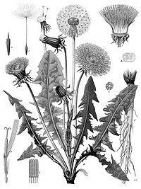
fracture is cartilaginous and short, not fibrous. The odour is faint and characteristic, taste is somewhat bitter.
Constituents. chlorogenic acid, cichoric acid, monocaffeoyl tartaric acids, taraxacoside, linoleic acid, linolenic acid, oleic acid and palmitic acid; Coumarins: cichoriin and aesculin; Flavonoids: Luteolin-7-glucoside and luteolin-7-diglucosides. Minerals: K 4.5% in leaf, 2.45% in root. It contains resin, undefined bitter complex (taraxacin); Terpenoids: sesquiterpene lactones taraxinic acid (germacranolide) esterified with glucose, and eudesmanolides. Other constituents include carotenoids, choline, inulin, pectin, phytosterols (e.g. sitosterol, stigmasterol, taraxasterol, homotaraxasterol), sugars (e.g. fructose, glucose, sucrose), triterpenes (e.g. b-amyrin, taraxol, taraxerol).
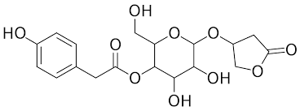Taraxacoside-b-D-glucoside
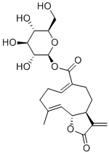Taraxinic acid O b-D-glucoside
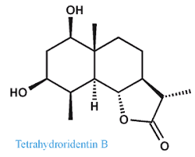Tetrahydroridentin B 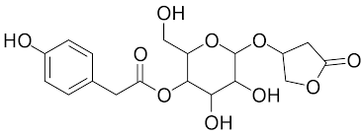Taraxacoside
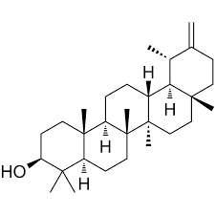 taraxasterol 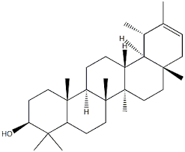 psi-taraxasterol
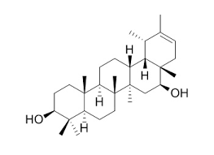 faradiol

Uses. Dandelion is stated to possess diuretic, laxative, cholagogue and antirheumatic properties. It has been used for cholecystitis, gallstones, jaundice, atonic dyspepsia with constipation, muscular rheumatism, oliguria, and specifically for cholecystitis and dyspepsia. The German Commission E approved use of root and herb for disturbance of bile flow, stimulation of diuresis, loss of appetite and dyspepsia. Root is used in combination with celandine herb and artichoke for epigastric discomfort due to functional disorders of the biliary system. Contraindications: Treatment with dandelion is contraindicated for patients with occlusion of bile duct, gall bladder empyema and obstructive ileus.
Side Effects: Animal studies indicate dandelion to be of low toxicity. Contact allergic reactions to dandelion have been documented, and animal studies have reported dandelion to have a weak sensitizing capacity. Sesquiterpene lactones are thought to be the allergenic principles in dandelion. These compounds contain an exocyclic a-methylene b-lactone moiety, which is thought to be a prerequisite for allergenic activity of sesquiterpene lactones.
Pharmacopoeial and Other Monographs: BHC 1992, BHP 1996, Complete German Commission E, ESCOP 2003, Martindale 35th edition, WHO monographs on medicinal plants commonly used in the Newly Independent States (2010).
HOPS FRUIT –LUPULI STROBILI
Hops - Humulus lupulus L., Fam. Cannabaceae.
Synonym(s): Humulus, Lupulus.
Plant. A 3 - 6 m tall (in cultivation up to more than 10 m) dioecious vine, twining to the right. 3-7-lobed long petioled leaves are coarsely pubescent, with a coarsely serrate margin. Female flowers are in stalked cone-like spikes.
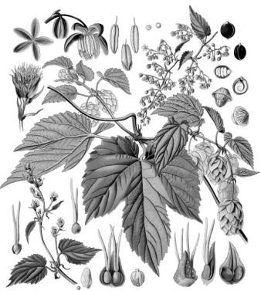
Area of distribution. Exclusively from cultivated female plants grown in many parts of the temperate zones, including Western Europe. India, China, and the USA.
Description. Hops consist of the 2-4 cm long, yellowish green female inflorescence (the hop or 'cone' or strobile), which is built up from imbricated oval bracts, in the axils of each of which are two female flowers, each one surrounded by a small oblique ovate bract. The leaf fragments of the drug clearly show the golden-yellow shining glandular trichomes (hop grains). The odour is intensely spicy. The taste is somewhat bitter and harsh. Hop grains are the glandular trichomes obtained from the hops by sieving. They form a greenish yellow to orange-yellow sticky powder. Odour: Characteristic, strongly spicy. Taste: Spicy and bitter.
Constituents: Bitter substances (acylphloroglucides) present in the resin, which is located in glandular trichomes (15 -30% in hops, 50 80% in hop grains). The most important component of the resin is the bitter substances humulone and lupulone. Many other bitter substances have been isolated in pure form. All the bitter substances are fairly labile compounds and on storage are slowly converted to components of the hard resin (mainly oxidation products). Essential oil (in hops 0.3 - 1%, in hop grains 1- 3%) is chiefly mono- and sesquiterpenes (myrcene, linalool, farnesene, caryophyllene. etc.; so far, more than 150 aroma substances have been identified). Tannins are also present, in the form of oligomeric proanthocyanidins (2 4% in hops, little in hop grains); and flavonoids (kaempferol and quercetin mono- and diglycosides, hop specific chalcone). A potent phytooestrogen have also been detected. Small amounts of phenol-carboxylic acids (ferulic and chlorogenic, etc.) are present.
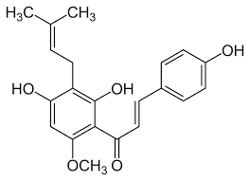Xanthohumol 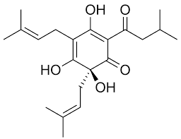Humulone
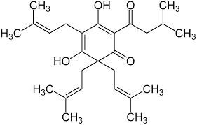 Lupulone 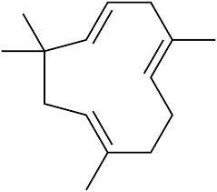Humulene

Uses. Hops are stated to possess
sedative, hypnotic and topical bactericidal properties. Traditionally, they have been used for neuralgia, insomnia, excitability, mucous colitis, topically for crural ulcers, and specifically for restlessness associated with nervous tension headache and/or indigestion. Hops are used in combination with valerian root for nervous sleeping disorders and conditions of unrest. Drug: Novo-Passit; Doppelherz Vitalotonik; Sanason, Urolesan, Valocordin.
Contraindications: Allergic reactions have been reported for hops, although only following external contact with the herb and oil.
Drug interactions. There are some conflicting data on the oestrogenic activity of hops, and 8- prenylnaringenin, documented as a constituent of hops, has been shown to have oestrogenic activity in preclinical studies. Herbs with oestrogenic effects may stimulate breast cancer growth. However, this requires confirmation.

